Science & Faith

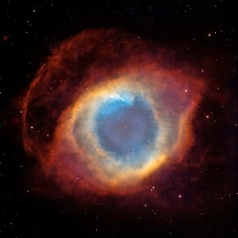
A Discussion Evening
Thursday 27th Sept
Dursley Tabernacle

Revd James Taylor, formerly a Cambridge biomedical research biologist, gave a presentation about evolution, creation, human origins and the conversation between Christian and atheist scientists.

Our own panel shared their views on the relationship between science and their Christian faith. Dr Dennis Allen is a physicist with a PhD in experimental condensed matter physics. Revd John Palmer is a retired engineering metallurgist, whose background is in chemistry and physics. Mr Lionel Jones is a physicist and retired nuclear engineer.

Science and Faith

Presentation by Revd James Taylor – 27th Sept Dursley Tab

Quotes:
I want to know God’s thoughts – the rest are details”. Albert Einstein”
“As a blind man has no idea of colours, so we have no idea of the manner by which the all-wise God perceives and understands all things.” Sir Isaac Newton
We have a chance to see God as the greatest scientist. As we discover things about the world, we can appreciate the wonders of God’s creation. What a gift it is to be a scientist and be able to do that”. Francis Collins

Science versus Faith?
Professor Richard Dawkins FRS FRSL
- Emeritus fellow of New College, Oxford
- Professor for the Public Understanding of Science
- Founder of the Richard Dawkins Foundation for Reason and Science
- The Selfish Gene (1976)
- The Blind Watchmaker (1986)
- The God Delusion (2006)

Professor Antony Flew
- Professor of Philosophy, Keele
- Professor of Philosophy, Reading
- The Presumption of Atheism (1976)
- Atheistic Humanism (1993)
- There is a God: How the World's Most Notorious Atheist Changed His Mind (2007)
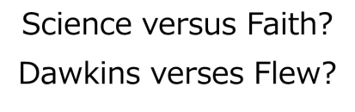
‘We might be seeing something similar today in the over-publicised tergiversation of the philosopher Antony Flew, who announced in his old age that he had been converted to belief in some sort of deity (triggering a frenzy of eager repetition all around the Internet).’ (The God Delusion 2006, p82)
This whole business makes all too clear that Dawkins is not interested in the truth as such but is primarily concerned to discredit an ideological opponent by any available means. That would itself constitute sufficient reason for suspecting that the whole enterprise of The God Delusion was not, as it at least pretended to be, an attempt to discover and spread knowledge of the existence or non-existence of God but rather an attempt – an extremely successful one – to spread the author’s own convictions in this area. (Anthony Flew, 2007)

Professor Sir Brian Heap CBE FRS
- Director of the Babraham Institute
- Master of St Edmund's College, Cambridge
- Vice President of the Royal Society
- Founder member of the International Society for Science and Religion

Dr Denis Alexander
- Head of the Molecular Immunology Programme at the Babraham Institute
- Director of the Faraday Institute for Science and Religion, St Edmund’s College, Cambridge
- Rebuilding the Matrix - Science and Faith in the 21st Century (2001)
- Beyond Belief: Science, Faith and Ethical Challenges (2004)

According to a survey published in the British Journal ‘Nature’ in 1997...
- 40% of scientists believed in God
- 45% of scientists did not believe in God
- 14.5% described themselves as agnostics
This ratio of believers to non-believers has not changed in 80 years
EJ Larson and L Witham, 1997. Scientists are still keeping the faith. Nature 386, 435-436.

In the beginning, God?
‘By the word of the LORD were the heavens made, their starry host by the breath of his mouth.’ (Psalm 33:6)
‘Let them praise the name of the LORD, for he commanded and they were created.’ (Psalm 148:5)
‘God did not make them out of things that existed’ (2 Maccabees 7:28)
‘For by him all things were created: things in heaven and on earth, visible and invisible, whether thrones or powers or rulers or authorities; all things were created by him and for him.’ (Colossians 1:16)
1949: Sir Fred Hoyle coined the phrase ‘Big Bang’ in a radio broadcast in order to ridicule the idea that the universe had a beginning
1959: survey taken of leading American scientists: "What is your concept of the age of the universe?" Two thirds reply that the universe had no beginning (Scientific American, 1959)
1965: Penzias and Wilson first measure the amount of cosmic microwave background radiation (Astrophysical Journal Letters 1969)

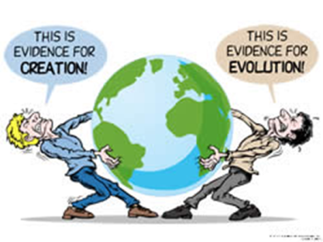
Creation verses Evolution?

Do we have to choose?

- ‘Let the land produce vegetation: seed-bearing plants and trees on the land that bear fruit with seed in it, according to their various kinds.’ (Genesis 1:11)
- ‘Let the water teem with living creatures’ (Genesis 1:20a)
- ‘let birds fly above the earth across the expanse of the sky.” (Genesis 1:20b)
- ‘Let the land produce living creatures according to their kinds: livestock, creatures that move along the ground, and wild animals, each according to its kind.” (Genesis 1:24)
- ‘Let us make man in our image’ (Genesis 1:26)

So what’s the problem?
- Evolutionary process is driven by chance
- Random genetic mutations that that are advantageous over time are inherited (genetic drift)
- So belief in a creator God is unnecessary and irrelevant
- “If the ‘tape of life’ were re-wound and played back, life would have taken a very different course” (Stephen Jay Gould)

Views on the origin of life on earth

Young Earth Creationism
- Six days of creation are literal
- Genealogy in Genesis and Matthew etc are literal and complete
- The universe is no more than 8,000 years old

Early Age Theory
- For a thousand years in your sight are like a day that has just gone by (Psalm 90:4)
- The universe/earth is very old
- “We know that it (a day of creation in Genesis) is different from the ordinary day with which we are familiar” St. Augustine

Intelligent Design (ID)
- The natural world displays the hand of a ‘designer’
- Irreducible complexity – certain features, such as eyes, are too complex to have evolved, so must have been created
Evolutionary creationism (theistic evolution)
- Evolution is the means by which God created life

Definition: the acquisition of the same biological trait in unrelated lineages.
Examples:
- the wings of bats, birds, and insects evolved independently from each other but all are used to perform the function of flying
- the complex eyes of vertebrates, cephalopods (squid and octopus), cubozoan jellyfish, and arthropods (insects, spiders, crustaceans) evolved separately, but all perform the function of vision

- Very similar shells of brachiopods and bivalve molluscs
- Prickles, thorns and spines have evolved independently to prevent or limit herbivory
- Plant hormones such as gibberellin and abscisic acid of plants and fungi
- Koalas of Australasia have evolved fingerprints, indistinguishable from those of humans and Apes
- Even intelligence itself has evolved in very separate species including corvids (crows), dolphins and primates

- “The presence of human beings, despite long odds against mankind's existence, is a miracle, and humans had to exist, exactly as we are.”
- “A world-picture that encompasses science but also the deep wisdom of theology may help us to explain how it is we can think, how we discover the extraordinary.”
- “It is the knowledge and experience of the Incarnation, the wisdom and warnings given by Jesus in the Gospels, and not least the Resurrection that in the final analysis are all that matters.” (Simon Conway Morris, 2004, Life’s Solution)

Science and Faith Resources
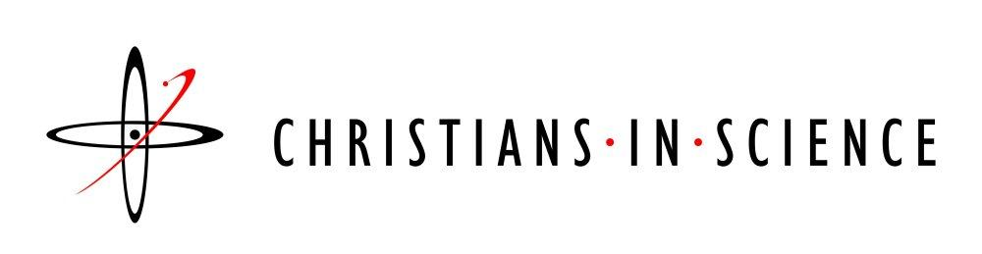
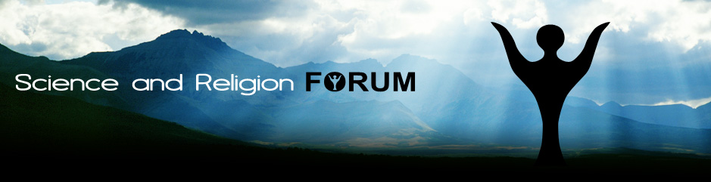

Would you Adam and Eve it?
“My acceptance of Adam and Eve as historical is not incompatible with my belief that several forms of pre-Adamic ‘hominid’ may have existed for thousands of years previously. These hominids began to advance culturally. They made their cave drawings and buried their dead. It is conceivable that God created Adam out of one of them.
...Adam was the first homo divinus, if I may coin a phrase, the first man to whom may be given the Biblical designation ‘made in the image of God’. John Stott, 2003, Understanding the Bible; p54-56

“I believe that God created man, and whether it came by an evolutionary process and at a certain point He took this person or being and made him a living soul or not, does not change the fact that God did create man. ... whichever way God did it makes no difference as to what man is and man's relationship to God.“
Billy Graham: Personal Thoughts of a Public Man, 1997. p. 72-74

Charles Darwin:
Champion of the atheist cause?
“There is a grandeur in this view of life, with its several powers having been originally breathed by the Creator into one”
Origin of Species. 1859, p429
“In my most extreme fluctuations I have never been an atheist in the sense of denying the existence of a God. I think that generally, and more and more so as I grow older - but not always - that an agnostic would be the more correct description of my state of mind.”
Charles Darwin. 1866, Letter to M.E Boole

Science and Faith – Dr Dennis Allen

Who am I?
I describe myself as a physicist. I have a doctorate in “Condensed Matter Physics”, which is a grand title for solids and liquids. I did an experimental PhD looking at the atomic-scale structures of liquid salts. I then spent several years as a postdoctoral Research Fellow at the Universities of Leicester and Birmingham. This included such diverse projects as radiography with neutrons, radiotherapy with neutrons and particle tracking using anti-matter.

About 12 years ago I moved into the business of nuclear safety when I came to work at the Berkeley Labs. I have since been sold off into a private consultancy business, along with about 60 others, and this summer we were sold again. But I am still a physicist, although I’m sometimes tempted to start calling myself an engineer.

One of the key qualities of a nuclear safety professional (whether a physicist or an engineer) is to have a questioning attitude. Perhaps if someone had asked the question “What makes you so sure you won’t have a tsunami greater than 5.7m” then events at Fukushima Daiichi could have turned out very differently.

So Why am I a Scientist?
A questioning attitude is what drives science forwards. It is also part of our human nature. What is science? It is not just a set of generally-accepted theories. It is more of a process whereby theories are put forward, most are rejected but some come to be generally accepted on the following basis: 1) they explain known observations, 2)
they produce testable predictions and 3) these predictions are seen to be true in observations and experiments. To become generally accepted new experimental results must be repeatable. The Higgs boson (whose idea, incidentally is as old as I am) is a great discovery which seems set to vindicate the seemingly outlandish theory of particle physics which predicted its existence - a particle which actually gives all other particles their mass! But, despite claims of “five sigma certainties” (1 in ~1.7 million), I think the discovery won’t be fully accepted until the observation is repeated elsewhere.

This is the great strength of science – not just its ability to answers some of the big questions like “How does the universe function?”, “How did life evolve?” and “How can we cure this cancer?”, but also its rigour. This is why I am a scientist. I have always had a fascination with these questions, especially the first, so I chose to study physics.

Science has been spectacularly successful in addressing these big questions, including the second. But there are still gaps. However those who seek to fill those gaps with God find them reducing in both size and number. The Christian God is not, and never was, a God of the gaps.

So Why am I a Christian?
I think there will always be questions unanswered by science. These are questions of meaning, morality and ultimate origin. Science may give us the laws (or is it theories?) of physics, but will never answer why they are the way they are. With fundamental constants finely tuned so that intelligent life can, or even must, evolve, the universe might be teeming with life. But that is only made possible because the laws of physics are so finely tuned to permit it. This does not of course prove the existence of an intelligent designer. Non-theists could counter that there are indeed many other universes, either in parallel or in series with the one in which we live, and that such fine tuning is inevitable in at least one of them. Neither I nor anyone else can disprove that – and there’s my point. If the theory can’t be tested by observation or experiment, then it’s not science. Multiple universes are no more a testable scientific hypothesis than God is. Both are a matter of faith. A matter of choice.

So why do I choose not to share the atheist’s faith? From a materialist point of view we may appear to be nothing more than a very complex collection of atoms. Yet we find ourselves gazing up at the stars and down even to the inside of those atoms and asking the most profound questions. Why? Would evolution alone produce such
inquisitive souls? What possible advantage is it for a species to invest so much time and effort hunting for the Higgs boson? It’s of no use to us whatsoever. I’ve no doubt that some atheists could provide some kind of answer to that question, but I’m not sure it would be a truly scientific answer.

Science has never compelled me to reject God. I believe it is because we are made in God’s image that we seek to understand God’s creation. Not simply to make use of it, but for the love of knowledge itself. It is because God wants us to know him that he has given us our inquisitive minds and came himself to dwell among us. That is why I am a scientist and why I am a Christian.
Science and Faith – Lionel Jones
For generations, my father’s side of the family have been coal-miners. And family history told me that anyone who stayed in that industry beyond the age of 30 suffered physical injury or lung disease. Only two men of the family got out before that age, my father was one of them. He had left school at 13 and went to the colliery to earn his keep as part of a growing family. But he also studied at night school, became a Methodist local preacher & at 25 he went to training college and became a minister. My great aunt was a district nurse and she had tended the casualties of a mining disaster at Wharncliffe in 1936 when 58 men died. I decided at a very young age that I wanted nothing to do with coal.
I was 16 when the Queen opened Britain’s first nuclear power station at Calder Hall, with a huge fanfare in the media about “electricity so cheap you wouldn’t need to meter it”. If only that had come true! But the message chimed with my distaste for coal fired electricity.
About the same time I found a book in the local library about the atomic bombs dropped on Hiroshima & Nagasaki in Japan, with horrendous pictures of the devastated cities and radiation burns to people. I realised there were only two likely uses for Uranium, and I was all in favour of “turning swords into ploughshares” as the Bible puts it.
In retrospect, these were probably the influences which steered me into working in nuclear power. I suppose I could call myself a nuclear physicist as I have a degree in physics, but that would be misleading to many who associate that label with things like the Large Hadron Collider or other big atom smashers. I know no more about the so called God Particle than most other people here. Instead, since I worked with engineers of almost all flavours, I call myself a nuclear engineer although I don’t have an engineering degree. I did 2 years experimental work at Harwell before joining one of the teams designing nuclear power stations, including Oldbury & Hinkley B in the west country, then coming to Berkeley Labs for more experimental work. I’ve worked on radiation shielding and the effects of radiation on steel, graphite, concrete, plastics – and on people. I’ve worked on the discharge of radioactivity into the atmosphere and into water. And some of my work has been part of the decision process which eventually closed down many of the power stations.
Christianity
I don’t think I have ever not been a Christian. Just like my voice has gradually changed from boy soprano, through alto, tenor & baritone to the lowest of the low, with no noticeable break, my faith has gradually changed from childlike trust in what I was told, to a willingness to question everything. When Jesus was asked which was the most important commandment he replied “Love God with all your heart, soul, mind & strength” which I take to be a deliberate mis-quotation/addition to the original commandment in Deuteronomy, which makes no mention of the mind. I think he was telling us that we don’t have to switch off our brains to be Christians.
If the writer of Genesis had been ordered to write in Egyptian hieroglyphs that the world was 14 billion years old, he would have needed the whole wall of this building to write the number down, and it would have meant no more to him than the number does to most people today, who still have no experience of such big numbers in ordinary life, except when politicians take about budget deficits!
Where most other nations had creation stories, they were about a pantheon of gods with all the worst human characteristics. Anger, greed, lust , incest, rape, patricide, infanticide, cannibalism. The importance difference in the Genesis creation is that everything was the work of one supernatural being who was a benevolent father figure. The creator and his works are not malevolent! That is the revolutionary difference.
If Jesus had talked about illness in neurological terms, or genetic disorder or bacterial infection, nobody would have understood him because everyone understood it as demon possession. He used the language of his time.
If he had argued with the Pharisees without quoting the law & prophets, he would have been dismissed as uneducated, because that was the only way scholars discussed moral issues.
The one commandment I cannot find in the Bible, is the requirement to believe that every word of the bible is literally true and dictated by God to human robots who copied it down infallibly, and that subsequently translators produced even one English version which carried the exact true meaning to all readers. To me that is a totally un-necessary article of faith. And that article of faith is the cause of most of the apparent conflict between science and Christianity.

Metallurgy and faith – Revd JohnPalmer
School Assembly - “Sir, did you ever have a job??”

Many years earlier, and after serving in the Army, I joined the Rolls-Royce Aero Engine Division in Derby, and trained as an Engineering Metallurgist, eventually specialising in the failure investigation of aircraft engine components both in flight and in ground-based facilities.

When Rolls-Royce crashed financially in 1971 I went to work at the Berkeley Nuclear Laboratories in the Tribology Department, investigating the effects of friction and wear between moving parts in nuclear reactors.

It was during this time that I finally responded to the persistent call of God in my life and I candidated and was accepted for the Methodist Ministry. I trained at Wesley College, Bristol, and was ordained in 1982.

I still had a lot to learn and throughout my Christian journey, through continued study, reading, and learning in fellowship with others on the same journey. On the way I have often had to change my mind - to re-think and sometimes let go of long-held believes and to see many old truths in a new light. It’s not always easy - and it can be painful.

Years ago, a very wise friend said to me: “Promise me, that you will always keep your mind open to the possibility of New Truth”. I hope I have kept that promise.

There never was a time when I doubted my Christian experience - there was a day when I first gave my life to Christ and he became my Lord and Saviour…
Nor is there any conflict between my Christian faith and the sciences that are behind my understanding of how our universe, our world and the people and creatures in it came into existence. - changing and evolving over billions of years.
For me, our understanding of evolution, with its process of natural selection, is God slowly drawing back the curtain, revealing more and more of His creation and encouraging us to go on questioning and discovering.

There is much I do not understand - and probably never will …… there is the ‘Otherness’ in the world, and in the human heart, which is the presence of the Divine and for which there is no equation or formula - but I am content to understand what I can and to stand under the rest.

The 18thc hymn-writer Isaac Watts got it right when he wrote:

‘Almighty God, to Thee
Be endless honours done,
The undivided Three, and the mysterious One.
Where reason fails, with all her powers,
There faith prevails, and love adores.

