27th April 2014: The Great Commission
Matthew 28.16-20
The disciples of Jesus must have been amazed and shocked that he’d been raised from the dead. In this familiar conclusion to the end of Matthews’s gospel they gather to hear what happens next? What happens next is that Jesus does not tear a strip off them or disown them for having let him down. Instead he commissions them with a great task.
The passage is loaded with significance for the Church of all ages and the question – what are we here for?
David Cameron's remarks that the UK is a "Christian country" were criticised by a group of public figures. Writing for the Church Times, the prime minister said British people should "be more confident about our status as a Christian country".
In response, 50 prominent individuals including authors, broadcasters, comedians and scientists added their names to a letter to the Daily Telegraph which argued the UK was a largely "non-religious society". Two senior Conservative ministers have backed the prime minister, arguing that those who deny the UK is a Christian country are "deluding themselves". They also suggested that Christians keep quiet about their faith for fear of being labelled a fundamentalist and being regarded as homophobic, or as creationists and anti-science etc.
In many respects it is easier being a Christian in the United Sates than it is in Britain. 40% of the US population say they go to church. In the South of the USA, Christianity is on the billposters and on the TV. People are more open, confident and even proud to go Church.. Going to church is deviant behaviour here. Over there it is not only acceptable but verging on the normal.
Consequently if you perceive that a substantial proportion of the population believe like you, you perhaps have less doubt about your belief. In sceptical Britain it is no wonder that most of us have our doubts and struggles of faith. We are in a predominantly secular environment that is antagonistic to faith. It is human nature to go along with the crowd, to adopt the values and beliefs of the majority. It takes an act of courage and even defiance to stand apart, to stand out.
It is easy to identify with the 11 disciples. At the sight of the risen Jesus, they worshipped, but their worship was mingled with doubt. The sight of him did not remove all the uncertainties and questions. The eleven wavered between adoration and indecision, between prayer and puzzlement. And they had the risen Christ in front of them! As John reported Jesus saying in his gospel ‘happy are they who find faith without seeing me. (John 19.29).
What is striking; however, is that the disciples are not excluded because of their questions? In fact, it is precisely to these followers, who are worshipping and doubting that the great commission is given. Those questions we have about our faith can move us forward into a deeper awareness of God. As St Anselm put it: we come from the position of ‘faith seeking understanding’.
It was to disciples who had faith but also had doubts and questions, that Jesus entrusted his work and gave this commission.
First of all Jesus announces the premise on which the great commission rests. Behind the imperative stands divine authority. Jesus has the right to command the Eleven to ‘make disciples’ because all authority in heaven and on earth’ has been given to him. We can often read these words without taking in their significance.
We live in a society which extols the principle of individual choice. We are our own authority. We make our own decisions. These first Christians had to come to terms with the impact of Christ on their lives. If he has been raised from the dead, and is seated at God’s right hand, then he is the Boss. That does not mean that we become robots, nor subservient, but in every generation those who profess the name of Christian, who confess that Jesus is Lord, have had to grapple with the consequences of that confession.
Poor old David Moyes. He was on a hiding to nothing when he took the job as manager of Manchester United trying to follow in the footsteps of Sir Alex Ferguson. How can you bring your own authority when compared to the giant of football management that Ferguson was.
The resurrection, as I said last week, vindicates Jesus, proclaims him the victor over the forces of suffering, evil and death. He has the authority. Of course we are free to go our own way, follow whoever we want. That’s our free choice. But the Christian faith says that the reality is that Jesus is the Boss.
Everyone in their own context has to work out how their faith affects their life. The German Theologian Dietrich Bonhoeffer, who opposed the Nazis and was eventually executed by them, put it succinctly: ‘In every situation we need to ask ‘what is Jesus Christ for us today?’
Jesus’ statement of authority is coupled with commission. The word ‘authority’ carries not only a warrant, but also the notion of power. The disciples are given confidence to carry out their mission because Jesus is Lord of all and present with them at all times. They are invited to take part in an activity by the Commissioner whose power they have seen in action. The mission to which they are called is not jeopardized by their weaknesses or limited by their uncertainties.
Authority and power often get confused. A policeman may have the authority to stand in the middle of the road and stop the traffic. But he may not have the power to do so and will have to jump aside to avoid being killed. A jailor may have the power, demonstrated by his bunch of keys, to open a prison cell and release a prisoner, but he may lack the authority to do it. Jesus had both the authority and the power.
Power can never be used without the right authority. A soldier must not fire his rifle unless he is ordered to. Many times in Jesus ministry, he waits to receive authority from his heavenly Father before acting. Waiting on God’s guidance is always vital for Christian ministry.
However , the commission Jesus gives here applies to the big picture – what we are about. In word and deed we are to be agents of the kingdom of God – to extend the authority of Jesus throughout the world – to answer the prayer ‘your kingdom come, your will be done on earth as it is in heaven’.
The work of Jesus to push back evil and suffering, greed,corruption and every kind of wickedness – is going to be our commission.
Jesus confronts the disciples with this awesome commission. The last two thousand years of church history has seen that task carried out with mixed blessings. The legacy of crusades, genocide, slavery, autocracy, and cruelty – all in the name of Christ – can make us flinch at this evangelistic commission. For too many it has been oppressive and abusive.
There are important debates on how we understand this commission of Jesus today. Certainly, whenever we ‘go in the name of Christ’ we engage in mission in Christ’s way. Jesus didn’t coerce or brow beat. He didn’t threaten. He came as a servant, he came to heal, to challenge, to share himself and lay down his life that others may live. It is an awesome commission to follow his way.
I came across this story on the BBC website the other day of a dutch priest who was killed a couple f weeks ago in Syria:

Frans van der Lugt: A Dutch priest in Homs
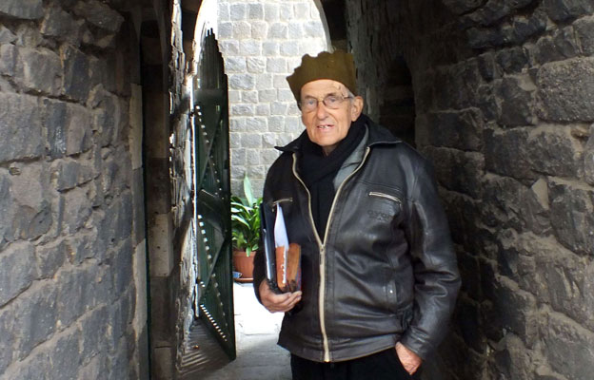
A Dutch Catholic priest was shot dead in the Syrian city of Homs earlier this month, but who was he, and what was he doing there? Bethlehem-based writer Daniel Silas Adamson pays tribute to a Jesuit who practised yoga, ran a farm and welcomed people of all faiths on mountain hikes.
No-one who knew Frans van der Lugt, the Dutch Jesuit priest murdered in Syria, was surprised by his refusal to leave the besieged city of Homs. He had spent almost 50 years in Syria and had been in Homs since the siege began more than two years ago.
The last European left inside the Old City, he was sought out by journalists and became a spokesman for the trapped and starving civilian population. "I have learned about the generosity of the Syrian people," he told a reporter earlier this year. "If these people are suffering now I want to be in solidarity with them. As I was with these people in their good times, I am with them in their pain."
A few years ago, I met Frans at the residence in Homs where, on 7 April, he was taken into the garden by a masked gunman and shot in the head. We were introduced by Paolo dall Oglio, an Italian priest who also spent his life in Syria and has not been seen or heard of since he was kidnapped by Islamist rebels in Raqqa in July 2013.
In many ways the two men were similar. Both were Jesuits. Both spoke fluent Arabic and considered Syria home. Both had been shaped by the ideals of internationalism and social justice that influenced the Catholic Church in the 1960s. In Syria, far from the rigid hierarchies of the Vatican, Frans and Paolo each found the freedom to pursue an unorthodox vision of what it meant to be a Catholic priest.
But they responded in radically different ways to the challenge of serving a dwindling Christian community in a predominantly Muslim country.
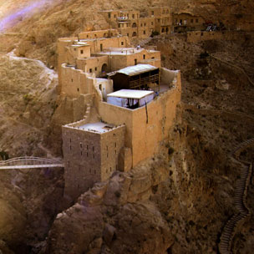
Paolo built on the bedrock of Syrian Christianity - desert monasticism. In the 1980s he found a ruined Byzantine monastery in the mountains some 80km (50 miles) north of Damascus and slowly restored it to life. Deir Mar Musa, as the monastery was called in Arabic, had been founded before Islam and only abandoned in the mid-19th Century.
For Paolo, it was witness to centuries of coexistence between Christians and Muslims and was, for that reason, an ideal place from which to promote friendship across lines of religious difference. He received thousands of Muslim guests at Deir Mar Musa, always making clear that they were welcome to eat, to sleep, and to pray at the monastery. Often he would show them the frescoes in the church, pointing out the 12th Century painting of Abraham (for Muslims, the Prophet Ibrahim) that covered the west wall.
"I believe in traditions, and the oriental tradition is rich and full of value," Paolo told me as we drove from Deir Mar Musa to meet Frans in Homs. "Fourteen centuries of common life between Christians and Muslims is not something to be cast aside lightly."

In the early 1990s, while Paolo was rebuilding his monastery in the desert, Frans was given a few acres of flat agricultural land about 15km south-west of Homs. He called it al-Ard - the earth - and he used it to create a spiritual centre that had no precedent in Syria.
"It's simple, like the earth," Frans said. "That's all."
The dirt track that led from the main road to al-Ard ran between olive groves and vineyards. Frans didn't use weed-killers or pesticides and there were wild flowers everywhere. In the centre of the land was a vegetable garden where perhaps a dozen people, many of them children or teenagers with disabilities, were weeding and watering the red earth.
Each morning Frans made a circuit of the nearby villages in his old VW van, collecting these young people from their families and bringing them to the farm. In a culture where people with disabilities are often hidden away in shame, Frans was creating a space where they could work together as part of "a community that values everybody".
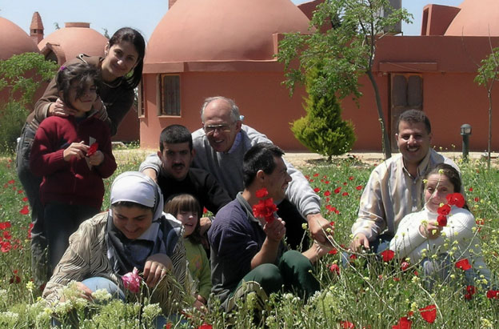
Some of these people needed patient, full-time support. Others, with less severe disabilities or mental health problems, were employed in the vineyards that made al-Ard economically sustainable.
The work was shared by the volunteers who lived on the farm and by those - of all faiths - who visited for spiritual retreats led by Frans.
Sceptical about initiatives that emphasised theological common ground, Frans rarely mentioned the Abrahamic roots shared by Syria's Christians and Muslims. If anything, he looked beyond monotheism entirely. He was a serious student of Zen Buddhism and sat in silent meditation every morning. He also taught meditation and yoga in a quiet, light-filled space, neither church nor mosque, that he built at the heart of al-Ard. "For me," he said, "it is important to start from the human meeting. Not to start with religion."
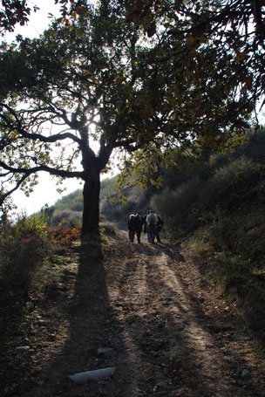
That lack of dogmatism may have been one of the things that drew young people to Frans. In 1980 he began walking through the Jebal Ansariya, the mountains that rise from Syria's Mediterranean coast, with students from his parish. Almost 30 years later, already in his 70s, Frans was still leading an annual eight-day hike across the country, followed by as many as 200 or 300 young Syrians - Christian and Muslim, Druze and Alawite. Though he was reluctant to ascribe any particular purpose to the walks, Frans acknowledged that they had become something special.
"The hike brings people together. They share the common experience of fatigue, of sleeping and eating together, and this builds a link between people. After the hike it is not important that you are Christian or Muslim, it is important that you are present."
Working on the land, sitting in silence, walking across the countryside. For Frans, these basic human experiences were the most reliable way to create "a kind of unity, a human complicity, a human comprehension". In the search for what he called "the common place of being" he had come to distrust the certainties that often accompany religious identity. Unless he was leading a service, Frans wore no outward signs of the priesthood to which he belonged and there was nothing at Al Ard that marked it out as a Christian space.
As he drove me back to Homs, Frans said: "You know, I don't really like religions. I believe in the spiritual experience that is the source, the initial inspiration of faith. Religions are always losing that inspiration, that direct experience; then they are not in the true way. I mean, they are in the hypocrisy of speaking for the spirit with which they have lost touch."
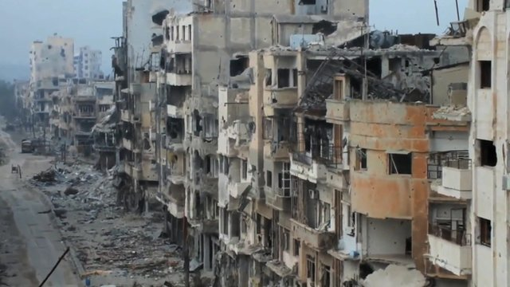
Father Frans and others describe life in besieged Homs (March 2014)
Frans, though, stayed true to his life's work. Through the appalling siege of Homs, his devotion to the Syrian people never faltered. To the end he spoke not of Christians or Muslims but of fellow human beings struggling to survive.
"There is nothing more painful than watching mothers searching for food for their children in the streets," he said in a video clip released in February. "We love life, we want to live. And we do not want to sink in a sea of pain and suffering."
Frans witnessed to the Risen Jesus in his life and gave his life for the people of Syria. He fulfilled his Lord’s Commission.

Three significant activities are mentioned as ingredients of the commission:
- Make disciples.
As Jesus called ordinary fishermen and trained them up as his followers, imitating his way of life and kingdom message, so his followers have the responsibility of calling men, women and children to follow him. It remains central to the way in which Jesus’ authority is brought to bear on the world.
- Baptise them into the name of the Father, the Son and the Holy Spirit.
Baptism implies a new belonging – a new identity. A relationship is established that marks them as a peculiar people. It is not an optional extra. Of course it is linked to Jesus death and resurrection: plunging through the waters – dying to an old life and rising to a new life following Christ. Baptism is the public, physical and visible way in which someone is marked out, branded almost, with the ‘holy name’.
If you go to a football match and you will see all the passion and the colours of the two teams, as supporters identify with their team. You can be left to wonder whether we have the same sense of identity and belonging to the church and are there any ways we can improve our sense of belonging and identity?
- Teach them to observe all that I have commanded you.
The Eleven are commissioned not only to instruct the baptised about what Jesus had said to them about the kingdom of God, to transmit his interpretations of the law, but also to teach them to obey Jesus. This task is only completed when the nations do in fact perform the teaching of Jesus.
This stress on teaching and obeying Jesus’ words protects the Christian message from being reduced either to cheap grace or to a private faith. The intent is to nurture a community that does not take God’s goodness lightly, but lives out in the world the discipleship to which it is called.
A healthy church will be a learning church. It doesn’t stop when you leave Sunday school. This time of year our young people are gearing up for exams. If they go on to University, if they start professional careers, they can look forward to many more years of examinations. At some point they may stop.
You never stop being examined as a Christian. We go on learning and growing. Hopefully that process isn’t too painful though. If we gave as much energy to learning about being disciples and putting it into practice, as we do to learning so many other things, then I’m sure we would make more headway with the gospel than we usually seem to do.
Our Christianity Explored Course at the Courtyard Café involved a couple of dozen of people. They all seemed keen to keep the learning and the discussing going. So we are about to embark on the sequel – Discipleship Explored – which is based on Paul’s letter to the Philippians, and will look at how to live the Christian life. The meetings are open to all, whether or not you were part of the Christianity Explored Course.
Finally, Jesus never leaves his followers with a list of things to do. He promises the divine presence to the Church as it responds to the Commission. At the beginning of Matthew’s gospel we are told the Jesus name is Emmanuel which means God is with us. Along the way, they overhear the promise to the disciples that when they gather for worship, Jesus will be present. And now at the end of the story they read of this commission of Jesus to accompany his disciples.
The Church after Easter is not abandoned. Though sent out like sheep among the wolves, it can count on the attendance of the crucified and living Christ, even in its darkest hours.
In 25D nobody outside a remote town in Galilee had heard of Jesus. By 50AD there were riots in Rome because of him. By 65 AD his followers were being persecuted by the Roman Emperor. Once Rome got to know of him – the whole world would soon know of him. The age to come – the end of time is when God’s will, will be done on earth as it is in heaven. Every time we say the Lord’s Prayer we pledge ourselves to be part of that work and bring it closer.
Let us not lose sight of our commission.
I finish with a short story of how you can lose sight of the great commission.
On a dangerous seacoast where shipwrecks often occur, there was once a crude little lifesaving station. The building was just a hut, and there was only one boat. But the few dedicated members kept a constant watch over the sea, and with no thought for their own safety, went out day and night tirelessly searching for the lost.
Some of the people who were saved, and various others in the surrounding community, wanted to become associated with the lifesaving station and to give of their time and money for the support of its work. New boats were brought and new crews were trained. The little lifesaving station grew.
Some of the members of the lifesaving station were unhappy that the building was o small and so poorly equipped. They felt that a more comfortable place should be provided for those who were being saved from the sea. They replaced the emergency cots with beds and put better furniture in the enlarged building. Now the lifesaving station became a popular gathering place for its members, and they decorated it beautifully and furnished it exquisitely. It became sort of a club.
Fewer members were now interested in going to sea on lifesaving missions so they hired professional life boat crews who were specially trained to save lives. The lifesaving motif sill prevailed, and a ceremonial lifeboat was placed in the room in honour of all those people who had been saved in the past.
About that time a large ship was wrecked off the coast, and the hired crews brought in boatloads of cold, we and half drowned people. They were dirty and sick and some of them were from a foreign country and couldn’t speak their language. The beautiful new club was in chaos. So the property committee of the lifesaving station called an emergency meeting and decided to build a shower house outside the club where the victims of the shipwrecks could be cleaned up and properly instructed regarding the rules of the lifesaving station.
At the next meeting, there was a split in the club’s membership. Most of the members wanted to stop the club’s lifesaving activities because they were unpleasant and a hindrance to the normal social life of the club. Other members, however, insisted that the lifesaving was primary purpose of the club. They pointed out that they were still called a ‘lifesaving station’. But they were finally voted down and told that if they wanted to save lives, then they could start their own lifesaving station down the coast. They did.
As the years went by, the new lifesaving station experienced the same changes that ad occurred with the old. It evolved into a club, and yet another lifesaving station was founded. History continued to repeat itself, and along the sea coast a number of exclusive clubs sprang up. If you visit that shore today, many of those clubs are dilapidated and some are closed, as people have decided that there are better, less guilt-inducing ways of belonging to a club.
Shipwrecks are frequent in those waters, but most of the people drown.
There is a church I know that on the back wall over the main church doors, is written the words of the great commission. As church members leave on Sunday morning they are reminded of the adventure and task that Jesus sends us out to do:
‘Go, make disciples of all nations, baptise them in the name of the Father, Son and Holy Spirit, teach them to obey everything I have commanded you, and I will be with you always, to the end of time.’
Let’s never lose sight of what we need to be about.

Let us pray.
Holy God, Trinity of Love we give thanks and praise for a world full of wonder, for all that you made good, and for our lives in your service.
We give thanks for your love revealed in our frailty, and that even though we are weak and full of doubts you still take us up in your work for the world.
We give thanks you are revealed through Jesus and through his love you have called us into a community of faith. Help us to find our belonging here and enable us to work out what being a disciple of Christ mean. Help us to be a good and faithful witness to our Lord. We pray for the mission and witness of all your church, and particularly we remember ….
We give thanks for the work of your Spirit bringing truth and justice to the world. We particularly pray for the movement towards international economic justice which has emerged over the last years including cancelling the unplayable debt of poor countries, increasing aid and bringing about trade justice. We give thanks for the work of Christian Aid and all who will be collecting for them in the weeks to come and we pray for a more equal world were poverty is history.
We pray for healing between the nations that all may rejoice in your good news.
We pray for healing for those we name before you…
And we join our voices with angels and all the holy ones of God, to proclaim your glory: holy holy is the Lord God almighty, the whole earth is full of your glory.
Amen.

http://www.bbc.co.uk/news/magazine-27155474

