Sharpness United Reformed Church
1902-2016
A brief history

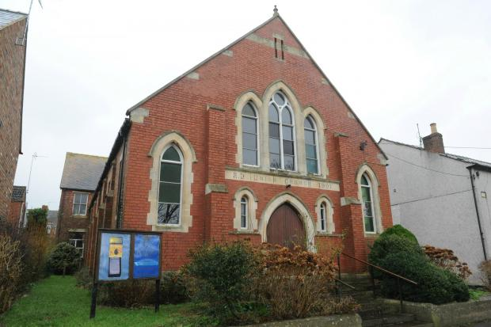

Sharpness United Reformed Church: A Brief History
The original church on this site was an iron building erected around 1879 to 1880 as an outreach from Berkeley Congregational Church. The growing population at Sharpness Point was felt in need of a nonconformist place of worship. £600 was raised to further the Christian mission to this settlement. A Sunday School grew rapidly to 150 pupils.
In 1898 the Revd William Bailey become the first minister. He was described as a Christian minister and gentleman. A man of faith and prayer. A great believer in and upholder of the fundamental truths of the Bible. He would be the minister for 20 years and his work would involve founding the Sunday School, the choir, visiting the sick in the community and the development and funding of the plans for the present church.
The present church was constructed on the site of the old between 1901 and 1902 and was opened on the 4th June 1902. The cost was £2000 which was paid off in six years. The wooden pews were manufactured on Gloucester and shipped won the river to Sharpness. Each was manhandled by Dockers, four to a large, two to a small, from the docks to the church.
On the opening day the following events are recorded. A prayer meeting took place at 5am of some 40 Dockers on their way to work. A similar meeting took place for church workers at 7am. A young people’s service took place at 10am. A communion service at 12pm. A lunch at 1pm the opening sermon was preached by Rev Thomas from Highbury Chapel, Bristol at 3pm with a congregation of 450. There followed an evening gathering.
Under the guidance of the Revd Bailey the church flourished. Indeed it was said of him that he epitomised the lines, ‘I shall pass through this world but once, therefore any good thing that I may do, or any kindness that I may show, let me do it now. Let me not neglect it as I shall not pass this way again.’
Mr F G Marling was also instrumental in the work of the Sunday School. The chapel became a centre of local community life. Organisations such as Christian Endeavour, the Choir and the Working Party (those who worked for the annual Sale of Work) all played their part. Out of chapel life also came the Sharpness Band.
The Revd Bailey preached his last sermon as pastor on 29th July 1917, using as a text 2 Cor 13.4 ‘the grace of the Lord Jesus Christ, the love of God and the fellowship of the Holy Spirit be with you all’ The pulpit has a memorial to remember the contribution of this outstanding man to the work of this church.
He was succeeded by Revd Collins Williams. It was his first church and he stayed at Sharpness for seven years. In 1928 Revd Palmer came to the church and remained in post until the outbreak of war in 1939. Again Sharpness was his first church. He and his wife held bible classes for young people. He was also known for his athletic ability which appealed to younger members.
Les Nash recalled some aspects of church life at this time. There were many bazaars held in the top room. Each had a theme and the one Les liked the best was ‘the rainbow’. All the participants were dressed in rainbow colours, the room was similarly decorated and there was a rainbow over the stage. There was also a memorable annual treat. All the adult members of the church together with the children would march behind a silver band to the Plantation Pleasure Grounds. The members of the Sunday School were dressed in house colours with hats and sashes. There followed an afternoon of sports, including a slow bicycle race, before tea prepared by the ladies of the church.
Following the resignation of Revd Palmer, the church could no longer afford the stipend of a full time minister. The Revd Davies from Berkeley cared for the church on a voluntary basis. The problems which beset the church during the Second World War were similar to those today in that they involved a continuous cycle of repairs to and maintenance of the building. Far more serious were the departure of so many young men from the community for active service. Forty three of whom died in service of their country.
The ARP used the vestry to be on call for emergencies and there were blackout curtains up in the upper hall. Despite the war, church activities both spiritual and social continued and there were annual Harvest festivals and Carol Services together with bazaars and sales. The church would not have another minister until 1949 when Pastor Bennett commenced his ministry. He didn’t stay long and for most of the fifties the church had no full time minister but were serviced by trainee ministers from Western College Bristol.
However during this decade the Sunday School continued to flourish. Audrey Long joined in the Sunday School in 1954 and recalls that she was one of seven teachers with many children attending. They had an active programme with trips to the seaside and the zoo, parties at Christmas and a gift service. The gifts were taken to the Dr Barnados home in Bristol. Children read the bible and sang hymns in church and some of the senior girls took part in the running of the Sunday School.
One story about the children at that time concerned the collection. When asked to bring some money to Sunday School the children said ‘why should we? Uncle Cyril Nash only puts it in his pocket!’ On being told this, next week Uncle Cyril brought his church cheque and account books to explain things.
By 1961 Lionel Anderson had become the minister of the church. He was a young minister straight out of Western College. At his ordination the preacher from the College said that all the students were praying they would receive a call to a church… but not to Sharpness! They were described as ‘rugged people’. Lionel Anderson would prove them wrong as he spent a happy and fruitful time at Sharpness for nine years. Together with a team of volunteers under the expert guidance of Ernie Chandler much was achieved in renovating the fabric of the building, redecorating, rearranging the seating and building new steps.
Following on from Lionel Anderson the Revd. Glynn Jenkins had oversight of Sharpness from 1977 until 1988. The church had joined the United Reformed Church in 1972 and became part of the Dursley Pastorate comprising of the Dursley Tabernacle, the Quarry and Sharpness. Within this community links have been loose so that whilst sharing ministry each of the three churches have largely maintained their independence.
After Glyn Jenkins, Colin Biggs became the minister in 1991 and stayed until 1994. He was succeeded by Revd Brian Sturtridge in 1996 who retired from ministry in 1999. During this decade the pastorate was also served by a non-stipendiary minister Lewis Reynolds. The Revd. Simon Helme has been the last minster of the church having been inducted into the pastorate in 2001. A change in the time of Sunday morning worship enabled Revd Helme to take morning worship at Sharpness on most Sundays in a year thereby sustaining regular ministry to the church. The church celebrated its centenary in 2002 by holding a flower festival and chartering a boat trip down the Sharpness Canal.
The last few decades have seen the gradual decline of the church in membership and activity. It has been a constant struggle to run the church on diminishing resources and morale. In the mid-1990s an attempt to restyle the church by converting part of the property to flats had its planning permission turned down. The church found funds from the Gloucestershire Environmental Trust to refurbish part of the building and has relied on the generous donations of church members to keep going since then.
Church life in the early part of the millennium had some activity namely the ladies Bright Hour and Boppers a parent and toddler group. Attempts were made to encourage the spiritual life of the church with an alpha course, meetings in the local pub, prayer meetings, bible studies, café church, after school clubs, pilots, all age services and joint services with the Anglican church of St Andrews. Unfortunately none of these ventures resulted in a reversal in the decline of membership. A partnership with the Berkeley players saw a number of Easter plays performed in the church to good reception and much appreciation.
As the church declined in numbers the burden of leadership fell on a few individuals over the last two decades. The church has been indebted to Pam Langford. Michele Everett and Michael Symes who have shared the role of church secretary during this time and to Claire Sayers who has been the church treasurer. Joan Symes has led worship on many occasions when the minister has not been available. Without the contributions of these individuals and the generosity of their time and money the church would have closed a long time ago. As it is the church meeting on January 10th 2016 decided, after much prayer and discernment, to close the church after over a hundred years of worship and witness.
We give thanks to God for all who have been part of the church throughout the years. We give thanks for the memories and important events this place has witnessed: the baptisms, weddings and funerals conducted here at important times of people’s lives. We give thanks for the nurture and care given through the members and ministers of the church. We have enjoyed the hymns sung in worship and by the choir. We are grateful for the children educated in the Christian faith through the Sunday School and the fellowship had in the various groups associated with the chapel.
We are thankful that through this place many have heard the good news: that God so Loved the World that He gave his only begotten Son that whosoever believeth in Him should not perish but have everlasting life.

