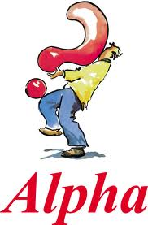
The Alpha Course – Tuesdays at 7.45pm
The Alpha course is open to anyone interested in discovering what Christianity is about. Come, relax, eat, share your thoughts and explore the meaning of life. Topics include Who is Jesus? Why and how to pray? Why and how to read the bible? Guidance. Healing. The holy spirit.
Find out more at http://uk.alpha.org
Publicity material and invitation leaflets, are in the vestibule and reception room. Speak to Simon (542344 or shelme@btinternet.com ) if you are interested in taking part.

First meeting on Tuesday 27th September is an introduction to the Course with a talk by Simon Helme on ‘Is there more to life than this?’
All welcome. Come along to find out more without any commitment to do the whole course

