**10th November 2024**

[**Call to worship**](javascript:void(0))

We are gathered together to meet one another.  
**Come, let us meet.**  
We are gathered together to remember and reflect.  
**Come, let us remember.**  
We are gathered together to pray and worship.  
**Come, let us worship.**  
We are gathered together to give.  
**Come, let us give of ourselves.**  
Give to the King of kings who gave his all for us.

[**A gathering prayer**](javascript:void(0))

Lord Jesus, you came for us, giving everything.  
Open our eyes afresh to see you;  
open our hearts to give;  
open our souls to worship;  
open our minds to be wise.  
Take us and use us for your glory.  
**Amen.**

[**A prayer of approach**](javascript:void(0))

Eternal God,  
we bring to you today our best and that which we know is not;  
we bring you our confidence and our insecurity;  
we bring all that we are and all that we long to be,  
to be nourished by your Word,  
to be uplifted by your Spirit and to be inspired by your Son,  
Jesus Christ, our friend and Saviour,  
by whose example we learn and in whose name we pray.  
**Amen.**

[**A prayer of adoration**](javascript:void(0))

Generous God,  
you give beyond what we deserve and can fully comprehend;  
and invite us to receive with grace and to share with joy.  
So we praise you for the blessings of faith  
and for the gifts of the Spirit;  
for the redeeming love of your Son  
and the promise of your kingdom;  
for the opportunity to give in your name  
and to grow in the likeness of Jesus Christ our Lord.  
**Amen.**

[**A prayer of confession and an Assurance of forgiveness**](javascript:void(0))

**A prayer of confession**

Dear God,  
forgive us when we are reluctant to give of our time and resources:  
**help us to be more like you.**  
Forgive us when giving feels like an obligation and not a delight:  
**help us to be more like you.**  
Forgive us when we are dismissive of small gifts and miss the love with which they are filled:  
**help us to be more like you.**  
Forgive us when we have abused the kindness of others and been greedy not grateful:  
**help us to be more like you.**  
In Jesus’ name we pray.  
**Amen.**

**Assurance of forgiveness**

Faithful God,  
you forgive and bless those who come to you;  
you fill those who are empty;  
you support those who are struggling;  
you encourage those tempted to give up on themselves  
and you give each of us the opportunity for a new beginning,  
which we receive now in Jesus’ name.  
**Amen.**

**Ruth was not just a refugee but she also crossed boundaries in order to show love for her mother in law.**

The Walled Off Hotel opened its doors this morning with some slightly different decor. Overnight Banksy had installed a brand new impressive piece of artwork in the hotel lounge opposite the reception.

The artwork is made from concrete and is a replica of the separation barrier, the 400-mile wall built by Israel along the West Bank, Bethlehem.

**[](https://www.graffitistreet.com/banksy-leaves-a-new-heartfelt-artwork-at-the-walled-off-hotel-2019/banksy-concrete-work-the-walled-off-hotel-west-bank-bethlehem-palestine-heart-pc-wisam-6/)**

The image is of a young girl playing the popular puzzle, the Shape Sorter Toy. The toy is simple, it has holes of different shapes, along with pieces that fit correctly into their respective holes. The shapes are usually circle, square, diamond etc.

**[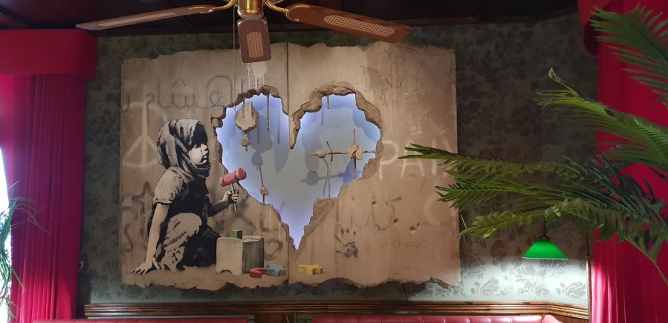](https://www.graffitistreet.com/banksy-leaves-a-new-heartfelt-artwork-at-the-walled-off-hotel-2019/banksy-concrete-work-the-walled-off-hotel-west-bank-bethlehem-palestine-heart-pc-wisam-2/)**

The young girl has different shapes to choose from such as, the traditional square in green, the symbol of the cross in yellow, and the Star of David in blue. She also holds a pink mallet in her left hand.

**[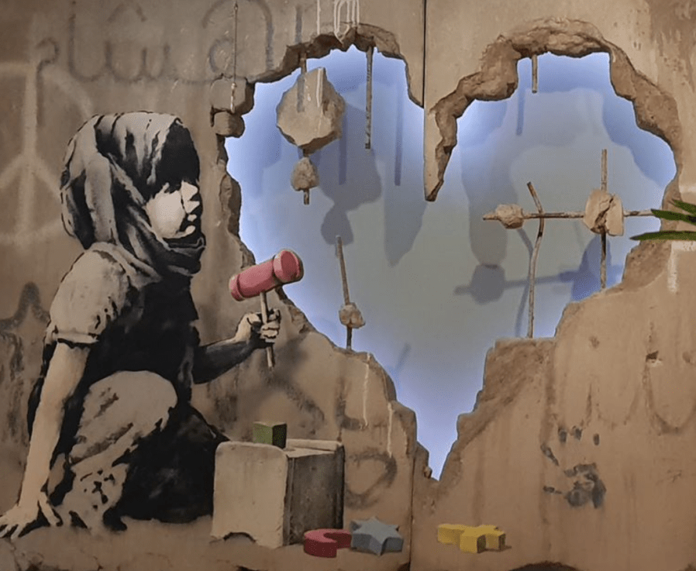](https://www.graffitistreet.com/banksy-leaves-a-new-heartfelt-artwork-at-the-walled-off-hotel-2019/screen-shot-2019-02-01-at-17-15-01/)**

The huge heart shaped hole hammered into the replica separation wall artwork could indicate love is the missing piece.

**[](https://www.graffitistreet.com/banksy-leaves-a-new-heartfelt-artwork-at-the-walled-off-hotel-2019/banksy-concrete-work-the-walled-off-hotel-west-bank-bethlehem-palestine-heart-pc-wisam-2/)**

What are your thoughts about this powerful new Banksy piece? Feel free to comment below.

**As it is Remembrance Sunday, Edith Cavell as an example of giving beyond obligation. Edith was a British nurse, working in Belgium when the First World War broke out. She encouraged the nurses to care for soldiers from both sides in the war. After the occupation of Belgium, Edith helped recovered soldiers escape to Holland. Colleagues urged her to return to England, but she refused. Eventually, she was betrayed, arrested, and executed for treason. Her statue in London bears the inscription: ‘Patriotism is not enough. I must have no hatred or bitterness for anyone.**

**Edith Louisa Cavell** ([/ˈkævəl/](https://en.wikipedia.org/wiki/Help:IPA/English) [*KAV-əl*](https://en.wikipedia.org/wiki/Help:Pronunciation_respelling_key); 4 December 1865 – 12 October 1915) was a British nurse. She is celebrated for treating wounded soldiers from both sides without discrimination during the [First World War](https://en.wikipedia.org/wiki/First_World_War) and for helping some 200 Allied soldiers escape from German-occupied Belgium. Cavell was arrested, [court-martialled](https://en.wikipedia.org/wiki/Court-martial) under [German military law](https://en.wikipedia.org/wiki/German_military_law) and sentenced to death by [firing squad](https://en.wikipedia.org/wiki/Firing_squad). Despite international pressure for mercy, the German government refused to commute her sentence, and she was shot. The execution received worldwide condemnation and extensive press coverage.

The night before her execution, she said, "Patriotism is not enough. I must have no hatred or bitterness towards anyone". These words were inscribed on the [Edith Cavell Memorial](https://en.wikipedia.org/wiki/Edith_Cavell_Memorial)[[1]](https://en.wikipedia.org/wiki/Edith_Cavell#cite_note-1) opposite the entrance to the [National Portrait Gallery](https://en.wikipedia.org/wiki/National_Portrait_Gallery,_London) near [Trafalgar Square](https://en.wikipedia.org/wiki/Trafalgar_Square). Her strong [Anglican](https://en.wikipedia.org/wiki/Anglicanism) beliefs propelled her to help all those who needed it, including both German and Allied soldiers. She was quoted as saying, "I can't stop while there are lives to be saved."[[2]](https://en.wikipedia.org/wiki/Edith_Cavell#cite_note-FOOTNOTEJudson1941-2) The [Church of England](https://en.wikipedia.org/wiki/Church_of_England) commemorates her in its [Calendar of Saints](https://en.wikipedia.org/wiki/Calendar_of_saints_(Church_of_England)) on 12 October.

Cavell, who was 49 at the time of her execution, was already notable as a pioneer of modern nursing in [Belgium](https://en.wikipedia.org/wiki/Belgium).

Her execution was represented as an act of German barbarism and moral depravity - very much at variance with Cavell's own clearly stated wish to have "no hatred or bitterness towards anyone."

Another representation of a side of Cavell during the First World War saw her described as a serious, reserved, brave, and patriotic woman who devoted her life to nursing and died to save others. Pastor Le Seur, the German army chaplain, recalled at the time of her execution, "I do not believe that Miss Cavell wanted to be a [martyr](https://en.wikipedia.org/wiki/Martyr) ... but she was ready to die for her country ... Miss Cavell was a very brave woman and a faithful [Christian](https://en.wikipedia.org/wiki/Christians)".[[4]](https://en.wikipedia.org/wiki/Edith_Cavell#cite_note-FOOTNOTEHoehling1957-4) Another account from Anglican chaplain, the Reverend Gahan, remembers Cavell's words, "I have no fear or shrinking; I have seen death so often it is not strange, or fearful to me!"[[19]](https://en.wikipedia.org/wiki/Edith_Cavell#cite_note-FOOTNOTEScovil1915-19) In this interpretation, her stoicism was seen as remarkable for a non-combatant woman, and brought her even greater renown than a man in similar circumstances would have received.[[26](https://en.wikipedia.org/wiki/Edith_Cavell#cite_note-FOOTNOTEHughes2005-26)

**Heart poppy craft E S**

**An act of commitment**

**You will need:** red paper (pre-cut into heart shapes), black tissue paper, glue, pens.

* Give everyone a heart shape. Invite everyone to consider who they might ‘give without obligation to’ this week – perhaps a family member, friend or neighbour. Write their name or draw them on the heart shape.
* Then join four heart shapes together at the point so that they make a poppy shape. Stick a scrunched-up piece of black tissue paper in the centre to complete the poppy shape.
* Hold the poppies up and use this simple prayer of commitment: Lord, we offer ourselves to you this week. We pray for all these people you have called us to serve. Help us to give ourselves without obligation so that we reflect your love.

**Ruth 1.1-18; 3:1–5; 4:13–17**

Women have been in the news these last two weeks. We had the first female Chancellor of the Exchequer give the budget last Wednesday. Described as a tax and spend budget, and a break with austerity dogma, it seeks to reinvest in Britina’s public services and infrastructure but is mainly getting businesses to pay for it. Time will tell whether this strategy works.

On Tuesday the United States decided not to elect its first ever female President in Kamala Harris, and chose instead Donald Trump, a liar and a felon convicted of sexual assault who has spoken of his desire to be a dictator should he regain the presidency.

Your news feed this week will have been full of events in America. Emotions are running high as everyone looks ahead for what this will mean for different communities in the US and around the World. America has always played a role in world affairs and people in the Middle East and Ukraine will be waiting anxiously for President Trump’s approach to their situations.

Today is Remembrance Sunday. We are remembering times when nations including Britain and the USA came together to stand against injustice and oppression. This was costly for nations who took action, for the individuals who gave their lives, and the communities who grieved those they lost.

Our readings today remind us that we’re called to give. God blesses us so that we are able to give away sacrificially to others. We give thanks to God for his goodness, for the example of others who have made sacrifices - up to their very lives, and we have to ask what is God asking us to give this week and in the years to come.

Our Bible readings these last two weeks come from Ruth, one of only two books in the Bible that bear the names of women – the other being Esther.

And this white middle class man gets to talk about her.

It is a story about a widow – or more precisely two widows Naomi and Ruth and how they have to find courage to face an anxious future. And a hidden question in the whole story is where we find God in all this tragedy and is there any hope. So it’s a bit like the story of Job that we have been looking at last month.

Just a bit of recap from last week. The book of Ruth begins as a story of Naomi. Naomi and her husband Elimelech flee Bethlehem – which means “house of bread” – because of famine. They settle in Moab, on the east side of the Dead Sea.

Alison Gray spoke about the issues Israel had with its neighbour Moab. There is a defamatory story in Genesis 19 of how the daughters of Lot got him drunk and then slept with him, got pregnant and their babies were the start of the tribe of Moab. You can imagine the chant on the football terraces should Israel play Moab.

Worse still Naomi’s sons marry Moabite women!

Years later, Naomi’s husband and sons die; she and her two Moabite daughters-in-law, Orpah and Ruth, are in a very vulnerable position. Naomi receives word that there is food again in Bethlehem and sets out for home, insisting that Orpah and Ruth return to their families. Ruth’s persistent refusal to leave Naomi’s side begins the turn toward renewal and transformation. Naomi and all of Israel will find a new future through Ruth.

Alison said last week this story is grounded in the theme of “turnings.” The Hebrew verb *shub* occurs twelve times in Ruth 1:1–18. At times, *shub* simply indicates a physical change in direction (1:15). Naomi also uses it to describe her perception of God’s rejection of her (1:13). Most accurate translation is that with the death of their husbands Naomi sees it as though *the hand of the Lord has turned against her.*

When we find ourselves in distress it is understandable to feel that the world and even God is against us. But the God found in the book of Ruth is primarily a God of blessing who is quietly at work to bring good out of this disaster. By the time this book ends, all sorts of unexpected turns and reversals will come.

In chapter 1 verses 19-21 Naomi says to the women back in Bethlehem, ‘Don’t call me Naomi,’ she told them. ‘Call me Mara, because the Almighty has made my life very bitter. **21**I went away full, but the Lord has brought me back empty. Why call me Naomi? The Lord has afflicted me; the Almighty has brought misfortune upon me.’

Naomi is disheartened and doesn’t hide her bitterness.

She refers to God as the Almighty – a formal and distanced term. She blames God for letting her life fall apart and is not afraid to say so.

The Psalms, as we discovered last week in our Bible Day, will suggest its OK to speak the way she does, though they may also suggest it’s a shame she’s not saying all this to God and not just about God.

Someone said’ Don’t complain to other people. Be sure to complain to God. God’s big enough to handle it.

When Naomi blesses Ruth and Orpah (1:8), she uses the Hebrew word *hesed*. *Hesed* expresses the love, loyalty, and commitment that one partner has for the other. Such loyalty exceeds legal requirements or duties. In the Hebrew Scriptures, *hesed* typically

describes God’s nature in covenant with Israel. However, beginning with her vow to Naomi (1:16–17), Ruth is established as an example and source of *hesed* in this story. Such loyalty will eventually restore Naomi’s faith. So Ruth and Naomi stick together and return to Bethlehem.

Naomi and Ruth were vulnerable widows looking for bread. Their journey brings God’s gifts of community and companionship; they are changed, as are those around them. When we are desperate – what a blessing to have people who will walk alongside us. What a blessing to know God is with us. When we are aware of that we have the hope that things may turn around.

Ruth chose to join her life’s journey with Naomi’s, forming an unlikely alliance for survival. In today’s scripture, these two widows navigate a decisive turning point. The stage for this account is set in the second chapter of Ruth, which tells of an encounter between Ruth and Naomi’s relative, Boaz. Ruth 2:20 identifies Boaz as “nearest kin.” The Hebrew word used here is *goel*. Elsewhere translated as “redeemer,” *goel* is a family member who is supposed to restore something that another family member has lost because of debt or poverty.

As Ruth 3 begins, Naomi and Ruth plan what they might do for the sake of their future security. Now ladies, I don’t know what your mother told you about how to find a man but Naomi’s advice is straight out of the tabloids!

In 3:3, Naomi proposes action filled with double meanings. She tells Ruth that Boaz will be winnowing barley down at the threshing floor. She should bathe and anoint herself with perfume and get dressed up and go down there but do not make yourself known to the man until he has finished eating and drinking.

“Do not make yourself *known…”* uses a verb that can also mean sexual intimacy (Genesis 4:1). Think of Adam and Eve knowing each other!.

“Threshing floor” has an association with sexual activity (Hosea 9:1). When the men had brought the harvest in they would eat and drink and get merry and the prostitutes, many of whom were widows because they had few other options for getting money to survive, would go down to the threshing floor with their perfume and fine dresses and get to know some men.

Is Naomi suggesting that Ruth play the whore?

Naomi then says when he lies down uncover his feet. “Feet” can be a euphemism in Hebrew for everything from the waist down. The translators of the Bible have always veered for the respectable and polite understanding of the word. In the context I think it is more likely it means uncover his genitals.

And then Naomi’s final advice after she has done all that is lie back (think of England – or Moab) and he will tell you what to do!

Honestly --- Mother in laws!

What is Naomi asking Ruth to do? To compromise Boaz and force him to marry her? To trick him into a marriage that his respectability would normally prevent him from contemplating? Whatever her thinking it is an extremely risky plan. She is asking Ruth to behave like a prostitute. She says she is seeking security for Ruth, but this is a funny way of going about it!

There is risk of offence for the sake of survival. Ruth follows Naomi’s counsel. She risked being seen as a whore and of offending Boaz. To cut the story short Boaz acts with honour as *goel* (“next of kin,” “one who redeems”) and marries Ruth. God gives conception.

Throughout the book of Ruth, Naomi and Ruth are models of persistence and loyalty. As the narrative closes, we learn how their relationship expands into a larger community of women. These women recognize the child’s importance to Naomi. “He shall be to you a *restorer* of life” (4:15). “Restorer” is a translation of the Hebrew *shub*, that word of “turning” used

throughout the book of Ruth. The women, not father or mother, name the child Obed.

A story of widows who have no living children becomes a story of birth. A struggle to survive becomes the means by which God restores hope to these women and to Israel’s unborn generations. God sets into motion a promise –through Ruth, the Moabite – for in her line David will eventually be born and then eventually the Son of David, Jesus of Nazareth will come to redeem the world.

The book of Ruth affirms that God works through surprising people and in unexpected ways in order to bring restoration to God’s people.

For centuries translators and interpreters of the Bible have portrayed Ruth as a model daughter in-law, indeed the ideal woman, humble, obedient, submissive, and deferential. They have made her into the character they have wanted her to be. But if we look at the story with open eyes, we will see it protests against such stereotyping. Ruth is determined, clever woman, who takes responsibility for her future, a passionate woman who is remarkable in her love and her loyalty.

This story is about gritty realities. The struggle for survival by any means, even if it means throwing yourself at a man. Somehow God uses it all – which is different from saying God approves of it all!

The gritty realties of War cause Christians to agonise over what is the right thing to do. We profess to follow the Prince of Peace, the one who did not resort to violence but who absorbed hatred. Who suffered to death on the cross and continued to forgive as the nails were hammered in his feet and his hands. The one who died and rose again to show us the love of God the faithfulness of God the hesed of God towards us. The floodgates of redemption were opened by his blood. Yet the cross of Christ can divide. It causes offence to the world but salvation for those who can see.

Like the story of Ruth, somehow through all these gritty realities God is working his purpose out.

God has hidden in the wings of this story of Ruth and only twice comes on stage. Once near the start to bring a famine to the end and again near the end, to give Ruth a child. But his name occurs many times, mostly in words of blessing.

Though in the bitter words of Naomi to the women of Bethlehem God is presented as the cause of great distress, the God of the book of Ruth is primarily a God of blessing. He brings prosperity where there is poverty, food where there is famine, fullness where there is emptiness, hope where there is despair and a child where there is an unspoken longing and endless disappointment.

The God of Ruth is one under whose wings can be found security and the most surprising love, for the book of Ruth is above all a love story. Yet is it not sentimental, nor solemn. With a playfulness and superb skill it tells of a love flourishing against all the odds, and against all that denies or cheapens humanity or rejects people because they are not our tribe.

We pray that God will be at work in the mess of war, against all that cheapens or denies humanity. We pray the widows created through conflict will find comfort and eventually turn from despair.

We pray for ourselves that we too will find shelter under the wings of God and the courage to trust that God is working to turn every situation for the good.

[**Prayers of intercession**](javascript:void(0))

Today we pause to think about those who gave beyond obligation during the two World Wars and many conflicts since. We thank you, Lord, for their dedication and service. We remember those who are in the armed forces today. Lord, protect them from harm as they seek to keep this world a safe place. And, Lord, more than anything, we pray for peace. May your Spirit hover over the earth and breathe peace into every continent, every nation, every people group, every adult, every child. Lord, we pray for peace. We thank you that you gave beyond obligation to bring the world back to you.  
Lord, we pray for peace.  
**Amen**.

Lord, there are so many areas of your world where there is nothing we can physically do to help… but we can pray. We lift the troubled areas to you: Ukraine, the Middle East, Spain, so many parts of Africa. Lord, pour out your love and healing over these places of conflict and fear. Help us to remember to pray… perhaps as we walk, or travel. Lord, may your kingdom come. And, Lord, if we are able, help us to give aid where it is needed most to help ease the suffering. Lord have mercy.

And we pray for the people of the USA as their new President is announced. May the result bring stability not division, we pray. We pray for wise leadership that will impact the world for good.

Lord, we bring our church to you now. Give us wisdom and vision so that we know where to place our prayers and our energies. Fire us up with your love to be a worshipping community that is known for its ability to care and live out the good news of your kingdom in practical ways in our local community. Help us to be prepared to go above and beyond to serve the needs of those around us. Inspire us to work together as the family of God.

Lord, we remember all those in our congregation who need a particular touch of your love right now. We pray for the sick, the sad, the anxious, the lonely, those waiting for hospital appointments or diagnoses.

Come alongside them in their need. Show us where we can be the answer to our own prayers and give us the insight to know when to speak, when to act, when to just sit in companionable silence.

Finally, Lord, we pray for ourselves. Sometimes we are so overwhelmed with busyness that we forget to pray. Or we forget to take care of ourselves or to find some space just to be… Lord, this week, as we think in the stillness now of all the things that need to be done, help us to find moments of calm and times to recharge our batteries. Show us ways in which we can give TO ourselves so that we become more fully the people you have created us to be. O Lord, who loves to give us good things, give us times of laughter and joy this week, times shared with friends, a meeting of minds, a joining of hands, a game well played or a meal enjoyed.

Lord, as we give of ourselves, replenish us with yourself. Go before us into every situation and help us to see you in the eyes of everyone we meet.

Lord, we give ourselves to you. Thank you for giving yourself to us.  
**Amen.**

[**A prayer of thanksgiving**](javascript:void(0))

Uplifting God,  
we give you thanks for the joy of giving and receiving;  
for those special people in our lives  
who makes us feel rich and cherished;  
for those who show us day by day the value of little things.  
Most of all, we praise you for your overwhelming and wonderful gifts  
of life and love and hope,  
reflected in your Son Jesus Christ,  
in whose name we pray.  
**Amen.**

[**A commitment prayer**](javascript:void(0))

Lord, Boaz gave from his wealth and opportunity;  
help us to give ourselves to you.  
The woman gave out of her devotion;  
help us to give ourselves to you.  
Lord, you gave your all for us;  
help us to give ourselves to you.  
**Amen.**

[**A sending out prayer**](javascript:void(0))

Use the final verse of Christina Rossetti’s hymn ‘In the bleak midwinter’ (beginning ‘What can I give him…’) as a prayer to say together.  
Or sing it… it’s only six weeks until Christmas!